DOCUMENTARY MEDICAL ARTICLE

“Codelac Phyto”: Codeine, Children Aged Two Years and Older, and the Price of a Suppressed Cough
A clinical pharmacology analysis of the OTC elixir manufactured by OJSC Pharmstandard-Leksredstva, its advertising, business model, corporate governance, and government oversight
Documented core fact | Finding
Active ingredient | Codeine phosphate hemihydrate, 4.5 mg per 5 mL
Paediatric dosing statement | Children aged two to five years: 5 mL per day, divided into 2-3 doses
Dispensing status | “Without a prescription” (OTC); confirmed at the federal level for at least 11 January 2007 through 31 May 2012
Manufacturer | OJSC Pharmstandard-Leksredstva
Advertising | In surviving broadcast copies from 2005: “syrup for children aged two years and older”
Version 1.0 • 5 August 2026 • Open sources and copies of primary documents

Main conclusion
THE ESSENCE
The government-approved instructions and corporate advertising combined, in a single consumer scenario, an opioid, a two-year-old child, a symptom that is protracted by its nature, and unrestricted purchase without a mandatory medical examination. What the parent received was not merely a “cough remedy,” but a bottle kept at home containing 10-25 daily codeine doses for the youngest specified age group.
Codeine does not treat a viral infection, influenza, pneumonia, Mycoplasma infection, or bronchial inflammation. It centrally reduces the cough response and is partially converted into morphine by the CYP2D6 enzyme. Morphine is what activates μ-opioid receptors, reduces respiratory drive, and can cause drowsiness, bradypnoea, hypoventilation, hypoxia, coma, and death. The individual rate at which morphine is formed is not apparent in advance to either a parent or a pharmacist. [S01, S27-S31]
For a two-year-old child, the combination of “respiratory disease + cough suppression + opioid-induced respiratory depression” created a dual risk. The cough reflex removes mucus and secretions; codeine can reduce their clearance. At the same time, exposure to morphine decreases ventilation. In pneumonia, productive bronchitis, bronchial obstruction, or another condition that reduces respiratory reserve, these mechanisms can compound one another. [S15, S18, S25, S29, S30]
A severe assessment does not require exaggeration. There is no evidence that every short course caused dependence, or that a therapeutic dose at the age of two programmed future heroin use. The established risk was immediate: morphine was formed after every dose, and the severe endpoint lay in the respiratory centre. With prolonged or repeated regular use, tolerance, physiological dependence, and withdrawal were added to that risk. [S27, S31, S32]
“HEROIN CAN WAIT” - THE MEDICALLY ACCURATE REPLACEMENT
It was not heroin that was “waiting” for the child. The immediate danger was already in the bottle: unpredictable formation of morphine, respiratory depression, a multi-dose supply kept at home and - with sufficiently prolonged regular use - physical dependence. Science does not permit attributing a proven pathway from this bottle to future heroin use.

Article map
- What Codelac Phyto actually contained, how much codeine a child received, and how many doses were in a bottle.
- Why the body needs the cough reflex and what happens when it is centrally suppressed.
- Acute respiratory viral infection, influenza, typical and atypical pneumonia, and bronchitis: consequences considered separately for children and adults.
- Acute intoxication, measurement errors, accidental ingestion, interactions, and delayed presentation for medical care.
- Tolerance, physiological dependence, withdrawal, and long-term consequences of severe hypoxia.
- Advertising, sales, owners, executives with medical education, and government decisions.
- Russian law, the Russian Federation’s international obligations, and international practice from 2000 to 2013.
1. Product profile: an opioid liquid for use at home
The official State Register of Medicinal Products (GRLS) instructions, registration No. R N002419/01-130808, identified the dosage form as an elixir. Each 5 mL contained 4.5 mg of codeine phosphate hemihydrate, and the pharmacotherapeutic group was stated explicitly: “opioid antitussive + expectorant.” The manufacturer was identified as OJSC Pharmstandard-Leksredstva. The dispensing condition was “Without a prescription.” [S01, S02]
Parameter | Documented value | Medical significance
Dose for children aged 2-5 years | 5 mL per day, divided into 2-3 doses | 4.5 mg of the codeine salt per day
If given in 2 doses | 2.5 mL per dose | 2.25 mg of the codeine salt per dose
If given in 3 doses | Approximately 1.67 mL per dose | 1.5 mg of the codeine salt per dose
50 mL bottle | 45 mg of the codeine salt | 10 labelled daily doses for children aged 2-5 years
100 mL bottle | 90 mg of the codeine salt | 20 such daily doses
125 mL bottle | 112.5 mg of the codeine salt | 25 such daily doses
The same absolute daily dose applied across the broad age range of two to five years. For a child weighing 10, 12, or 15 kg, this corresponded to approximately 0.45, 0.375, or 0.30 mg/kg/day of the stated salt, respectively. These figures are exposure calculations, not toxicity thresholds. They demonstrate that the smallest and lightest child received more per kilogram.
The instructions simultaneously claimed that codeine did not depress the respiratory centre at recommended doses, while listing respiratory failure and bronchial asthma as contraindications, respiratory-centre depression and bradypnoea as symptoms of overdose, naloxone as the antidote, and drug dependence as a possible consequence of prolonged use. Such a framework required clinical patient selection and an explanation of risk, but OTC status did not make a medical examination mandatory. [S01]
Figure 1. Official instructions: composition of 4.5 mg/5 mL and classification as an opioid antitussive.
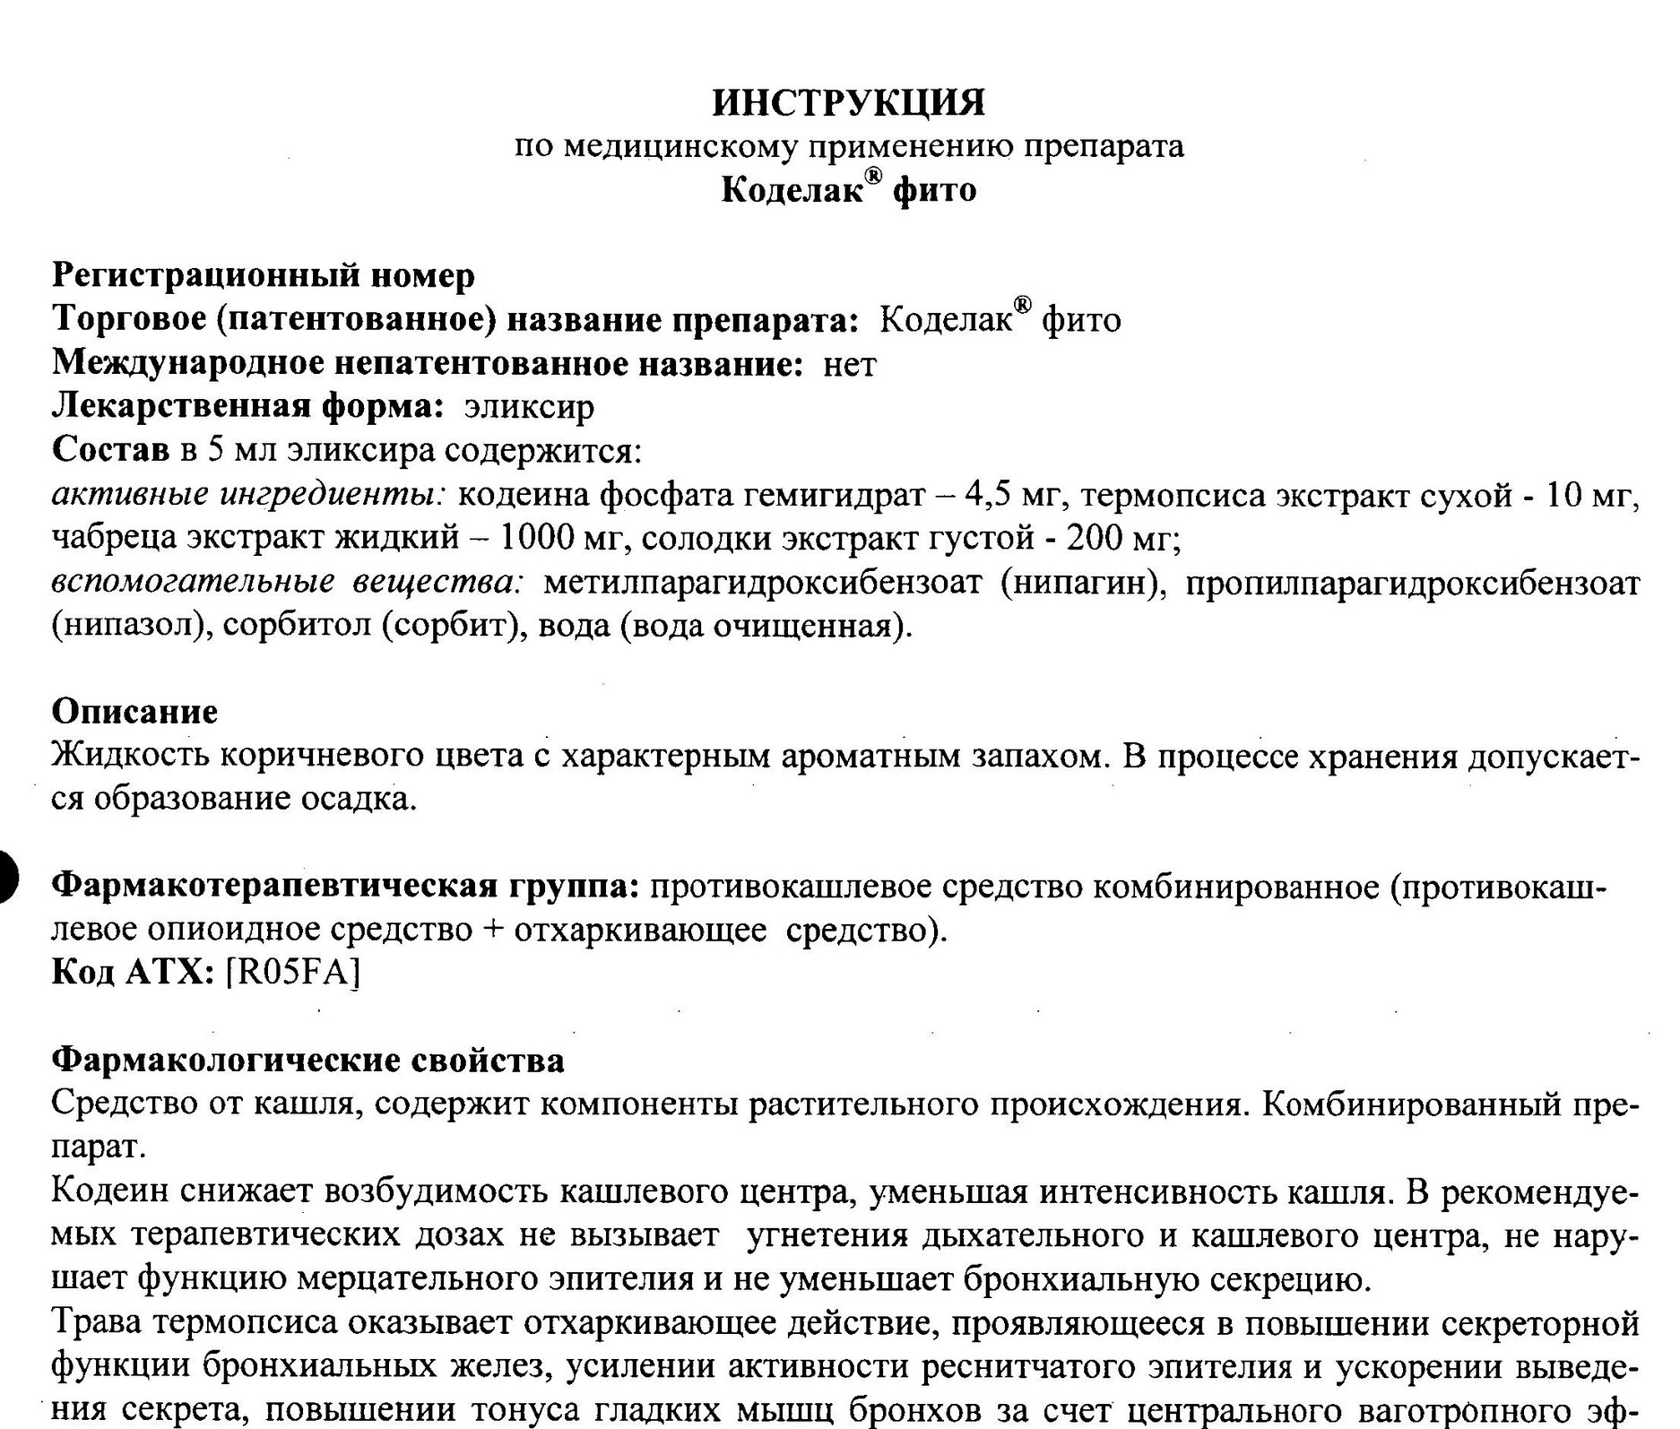
Figure 2. Official instructions: dosing for children aged two to fifteen years and the dependence warning.
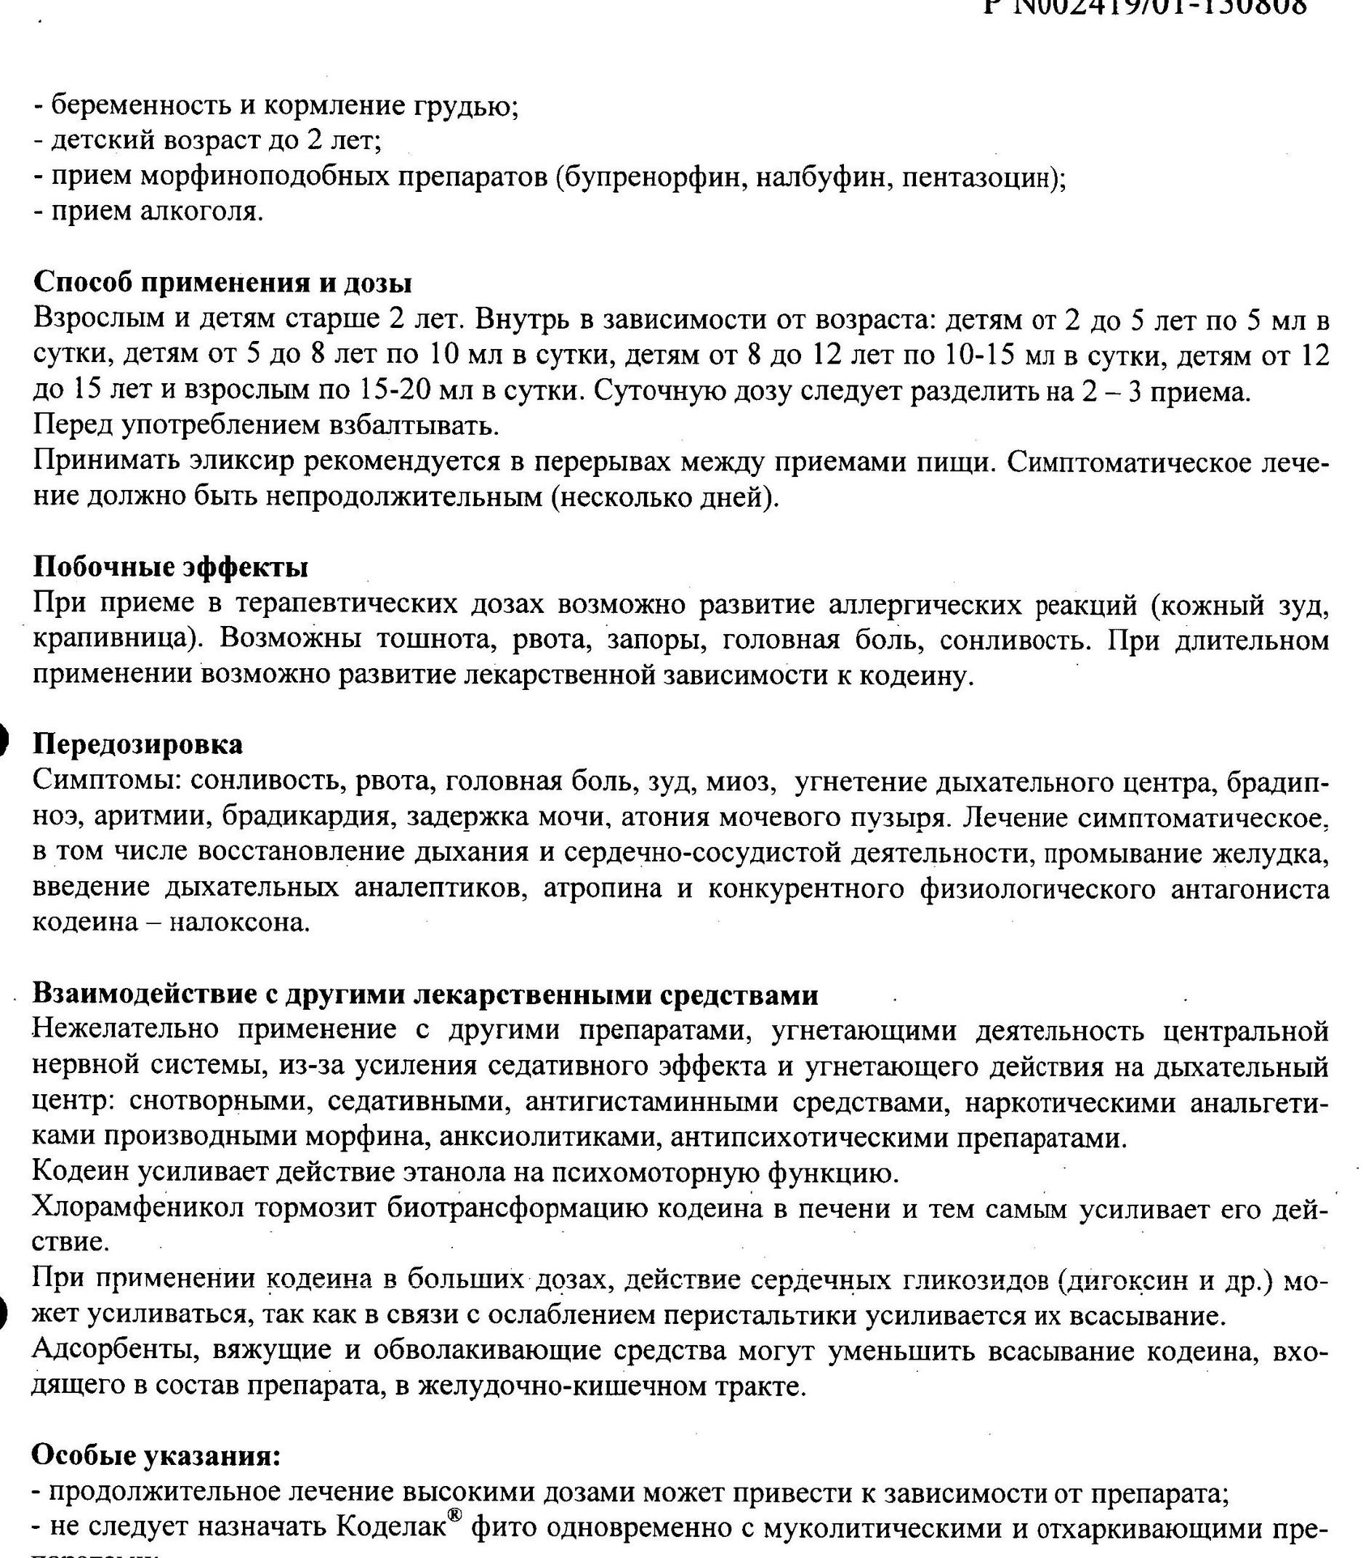
Figure 3. Official instructions: manufacturer OJSC Pharmstandard-Leksredstva and “Without a prescription.”
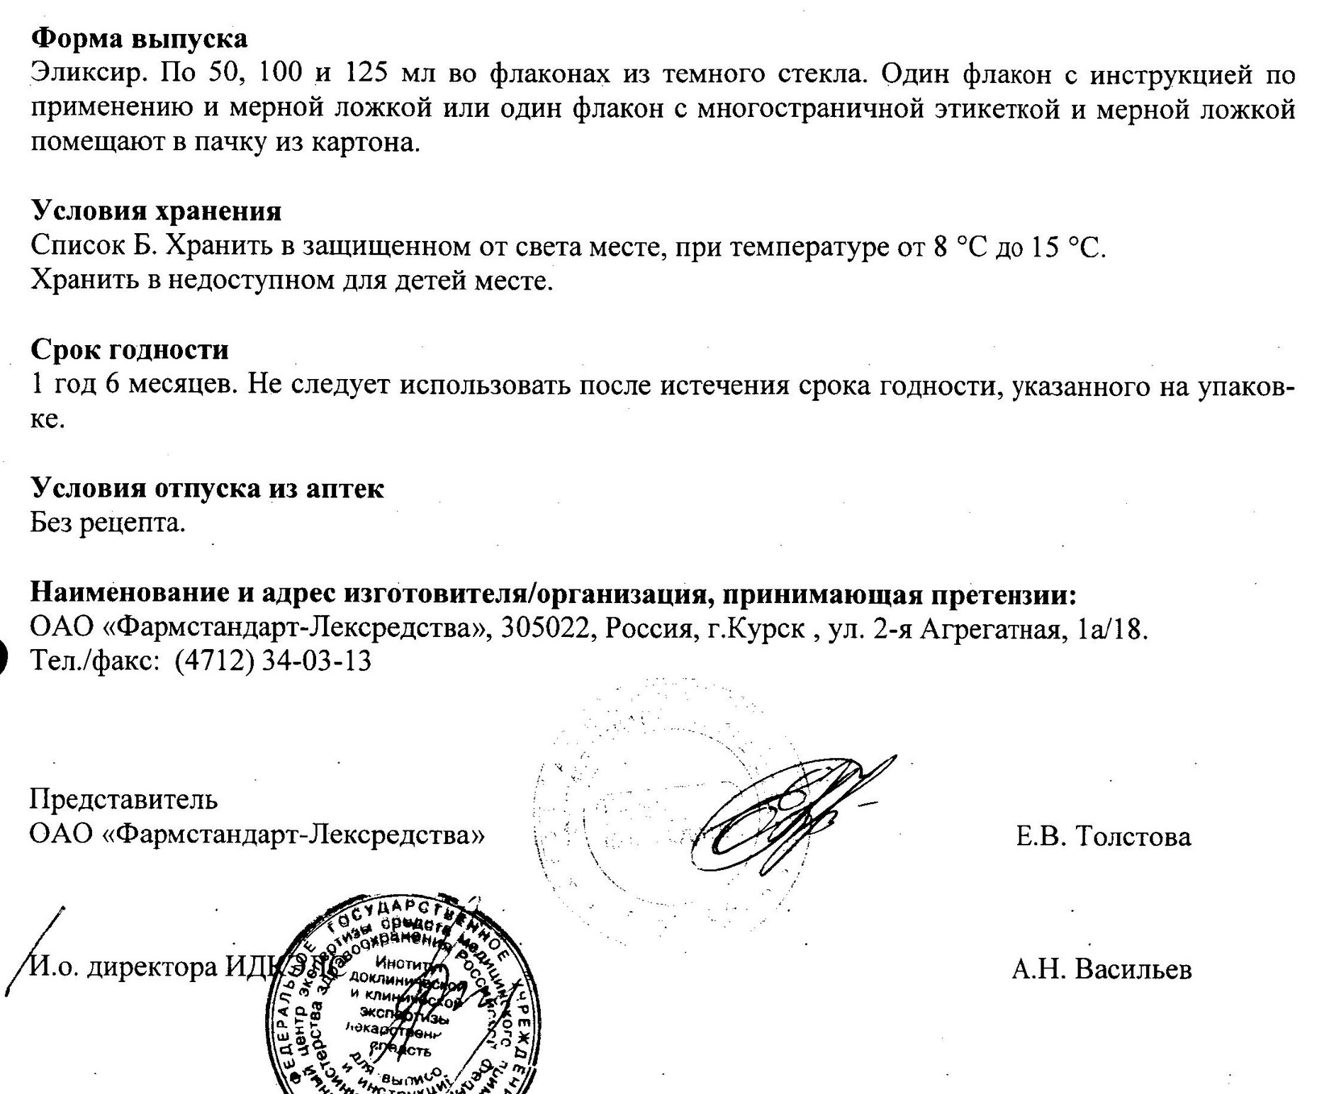
2. Cough is a protective reflex, not a separate disease
Cough occurs when receptors in the larynx, trachea, and bronchi detect mucus, inflammation, or an irritant. A deep breath, closure of the glottis, an increase in intrathoracic pressure, and a forceful exhalation create an airflow that moves secretions upwards. Together with mucociliary clearance, this is one of the principal mechanisms by which the airways clear themselves.
A centrally acting antitussive reduces the response of brainstem structures to the cough signal. This can provide symptomatic benefit for some adults with a genuinely dry, exhausting cough after its cause has been established. When secretions are present, however, suppressing the reflex neither resolves the inflammation nor thins the mucus; it can reduce mucus clearance. The American Academy of Pediatrics (AAP) emphasised this problem as early as 1978, and in 1997 pointed to the absence of convincing paediatric benefit and the risk of toxicity. In 2006, CHEST recommended against the use of cough suppressants and OTC cough medicines in children. [S15-S18]
A DOUBLE BLOW TO RESPIRATION
In lower respiratory tract disease, codeine can simultaneously weaken the mechanical clearance of the bronchi by coughing and reduce central respiratory drive through morphine. One mechanism promotes secretion retention; the other promotes hypoventilation. In a young child with narrow airways and limited reserve, this combination is particularly unfavourable.

Natural duration of cough
A cough associated with a respiratory infection is predictably not a one-day symptom. In a prospective cohort of children aged 0-4 years, half had stopped coughing by day 10, and 90% by day 25. These were the 50th and 90th percentiles, not arithmetic means. A 2013 BMJ systematic review confirmed the same benchmarks. In uncomplicated influenza, the main illness usually lasts 3-7 days, but cough and malaise can persist for more than two weeks. [S19-S21]
The implication for an at-home OTC scenario is clear: the instructions referred to “several days,” whereas the symptom itself often continued for two to three weeks. This created a foreseeable possibility of prolonging the course, repeating it, or giving an additional dose if parents interpreted persistent cough as treatment failure. The duration of the symptom does not prove that any particular family violated the instructions; it demonstrates why product design should have taken human behaviour into account.
3. What happens when cough is suppressed in different diseases
Children and adults, dry and productive cough, and upper and lower respiratory tract disease are considered separately below. This distinction is fundamental: the same symptom serves different functions in different clinical situations.
Condition | Children | Adults | Consequence of suppression
Acute respiratory viral infection / common cold | Codeine does not treat the virus. In young children, cough is often associated with mucus, postnasal drip, and inflammation; the opioid risk is disproportionate to the limited benefit. | For a distressing dry cough, brief symptomatic therapy is sometimes acceptable after contraindications have been assessed; codeine does not shorten the infection. | Drowsiness and reduced alertness; when secretions are present, less effective clearance. In a child, unpredictable morphine exposure is added.
Influenza | Cough may last more than two weeks. Suppression does not treat the virus and may make it more difficult to recognize pneumonia or respiratory deterioration early. | Brief relief of a dry cough is possible only when breathing is intact and there are no signs of complications; codeine is not a treatment for influenza. | Reducing the symptom can create a false impression of improvement; sedation may mask lethargy and worsening hypoxia.
Pneumonia | Cough helps clear secretions. Codeine does not treat the infection, can impede clearance, and can simultaneously depress breathing. For a young child, this is a clinically unacceptable combination of risks. | Routine suppression of productive cough is not justified. In the presence of hypoxaemia, dyspnoea, secretions, or reduced reserve, an opioid is especially dangerous. | Secretion retention, mucus plugs, atelectasis, and increased work of breathing; against a background of morphine-induced hypoventilation, worsening oxygenation.
Atypical pneumonia / Mycoplasma | Children younger than five may have wheezing and an atypical presentation. A persistent cough requires diagnosis; codeine has no activity against the pathogen. | The cough often begins as dry and may later become productive; an apparently mild course does not exclude pneumonia and complications. | Symptomatic “quieting” may delay reassessment; once sputum develops, suppression can impair clearance. When indicated, an antibiotic treats the cause; codeine does not.
Acute bronchitis | Routine suppressants are not recommended for children. When mucus is present, cough provides clearance; codeine adds sedative and respiratory risks without convincing benefit. | Cough and mucus can persist for up to three weeks. Brief relief of a severe dry nocturnal cough is sometimes considered, but not in the presence of sputum, dyspnoea, or suspected pneumonia. | In productive cough, a risk of secretion retention; reducing cough does not mean that the inflammation has resolved.

Acute respiratory viral infection in children
For a two-year-old child, the line between a “simple cough” and bronchiolitis, obstruction, incipient pneumonia, or a foreign body is not always apparent to a parent. OTC purchase bypassed mandatory assessment of respiratory rate, oxygen saturation, chest retractions, wheeze, dehydration, and concomitant medicines. A reduction in cough after codeine did not confirm recovery; drowsiness could be an adverse effect rather than restorative sleep.

Influenza in children and adults
Influenza can rapidly be complicated by viral or secondary bacterial pneumonia. Cough may persist after fever has subsided. Centrally suppressing it changes the observable symptom without acting on the virus, the inflammation, or oxygenation. Particularly dangerous signs are recurrence of fever, increasing dyspnoea, cyanosis, chest pain, marked lethargy, and reduced fluid intake: these are reasons for examination, not for increasing the antitussive dose. [S21]

Typical pneumonia
In pneumonia, the alveoli and small airways contain inflammatory exudate and respiratory reserve is reduced. Cough helps move secretions; the AAP expressly advises against the use of codeine- and dextromethorphan-containing suppressants in children because coughing clears excess secretions. Official labelling for opioid antitussives also warns against their use in an acute febrile illness with productive cough or when suppression of clearance would impair respiratory function. [S25, S30]
For children, the risk is more severe because of their smaller airway diameter, more rapid fatigue of the respiratory muscles, and variable morphine formation. In adults, too, an opioid is not routine treatment for pneumonia: respiratory depression becomes especially dangerous in the presence of sputum, hypoxaemia, COPD, sleep apnoea, advanced age, or concurrent use of alcohol, benzodiazepines, or other sedatives.

Atypical pneumonia
With Mycoplasma pneumoniae, onset is often gradual, the cough is persistent and initially dry, and sputum may appear later. The patient sometimes appears better than would be expected from the radiographic pneumonia, which is why the term “walking pneumonia” can be misleading. Cough suppression can further reduce the visibility of progression, but it does not treat the bacterium or prevent severe pneumonia, bronchial obstruction, or extrapulmonary complications. [S26]

Acute bronchitis
Acute bronchitis is often accompanied by mucus production and cough lasting up to three weeks. Routine central suppression of cough has no convincing benefit in children. In adults, there is a narrow scope for symptomatic use of certain non-codeine agents in a severe dry cough, but current NICE guidance explicitly excludes codeine from the OTC cough-suppressant options and notes that codeine offers no advantage over placebo for acute cough. [S22-S24]
PROFESSIONAL ASSESSMENT
Giving codeine to a two-year-old child with pneumonia, a febrile productive cough, bronchial obstruction, or impaired breathing is clinically unjustified: the drug does not treat the cause, may impede bronchial clearance, and can depress the respiratory centre. Unrestricted sale shifted recognition of these conditions to parents, while the regulator and manufacturer were simultaneously telling them that the medicine was intended for children aged two years and older.

4. Sequence of acute codeine intoxication
- Ingestion. The elixir enters the gastrointestinal tract; codeine is absorbed into the bloodstream.
- Bioactivation. CYP2D6 converts a portion of the codeine into morphine. The rate depends on genotype and interactions; the same spoonful does not guarantee the same morphine exposure.
- Action at μ-receptors. Morphine reduces the sensitivity of the respiratory centre to carbon dioxide, decreases the rate and depth of breathing, and causes drowsiness and miosis.
- Hypoventilation. Carbon dioxide increases and oxygen becomes deficient; the child is more difficult to awaken, while coughing and airway protection weaken.
- Decompensation. Slow, shallow breathing; unusual snoring or grunting; cyanosis; lethargy; stupor; apnoea; circulatory arrest.
- Emergency care. Stop administration, summon emergency medical assistance, and support the airway; naloxone is the antidote, but medical observation is required because toxicity may recur.
In its review of published cases involving codeine for cough, Health Canada identified 16 serious respiratory events in children aged 17 days to 6 years, five of which were fatal; in 13 cases, there was an accompanying respiratory illness, including respiratory tract infection. These were not Codelac Phyto statistics and do not establish the frequency of risk, but they directly confirm the dangerous combination of “codeine + diseased airways.” [S29]
RED FLAGS AFTER CODEINE
Unusual or increasing drowsiness; difficulty waking the child; confusion; very constricted pupils; slow, shallow, or irregular breathing; pauses in breathing; bluish lips; lethargy. These are not an expected “calming of the cough,” but signs of possible opioid toxicity.

5. Incorrect use: foreseeable system errors
Parents who purchased an authorised OTC product and followed the age-specific dosing statement were acting within the scenario presented to them. The safety failure lay in the system assigning a non-specialist the tasks of selecting the patient, recognising contraindications, accurately dividing a liquid dose, assessing effectiveness, and deciding how long the course should continue.
Scenario | Why it is possible | Medical consequence
Entire daily dose at once | 5 mL instead of 2.5 mL or approximately 1.67 mL as a single dose | A higher single-dose peak; the exact pharmacokinetics of the mixture in children have not been published
Repeat sooner | The cough did not disappear after the first dose | Increased total exposure and morphine burden
Prolong the course | Cough naturally persists for 10-25 days | Regular opioid exposure, tolerance, dependence, and withdrawal
Combine with a sedative | An antihistamine, hypnotic, benzodiazepine, or another opioid | Additive drowsiness and respiratory depression
Give for a productive cough | A parent did not distinguish between a dry and a wet cough | Reduced secretion clearance plus opioid-induced hypoventilation
Accidental ingestion | The bottle remains accessible to the child | Access to 10-25 labelled daily doses
In an experiment involving 2,110 parents, 84.4% made at least one error exceeding 20% when measuring a liquid medicine, and 21% made at least one error of more than twofold; most errors were overdoses. This was not a study of Codelac Phyto, but it demonstrates that liquid-dosing errors are a normal human-factors risk that the manufacturer and regulator are obliged to address in the product’s design. [S33]
The US Centers for Disease Control and Prevention (CDC) reported that children aged 2-5 years accounted for 64% of emergency-department visits for adverse events from cough/cold medicines, and nearly 80% of events in this age group involved unsupervised ingestion without an adult’s knowledge. The report concerned a variety of formulations, not codeine alone; nevertheless, it documented the mechanism of access to a bottle kept at home. The European Medicines Agency (EMA) later specifically required child-resistant containers for all liquid codeine medicines. [S28, S34]
6. Tolerance, physical dependence, and withdrawal
Tolerance means that the same dose produces less effect. Physiological dependence means that the body has adapted: abrupt discontinuation causes withdrawal symptoms. This is not the same as opioid use disorder, still less evidence of future non-medical use.
The AAP states that regular around-the-clock opioid administration can cause physiological dependence in approximately five days. However, the underlying evidence relates principally to analgesia and intensive care, often involving higher and continuous doses. It cannot be inferred from those data that five days of Codelac Phyto inevitably produced dependence. The product-specific incidence is unknown. The most direct evidence is the warning in the product’s own instructions: prolonged use may lead to the development of drug dependence on codeine. [S01, S32]
Stage | What happens | How it may appear in a child
Regular exposure | Repeated activation of μ-receptors | Drowsiness, constipation, and nausea; the effect on cough may weaken
Neuroadaptation | Tolerance and physical dependence | The previous dose appears less effective; there may be a tendency to prolong the course or increase the dose
Abrupt discontinuation | Opioid stimulation falls | Irritability, crying, insomnia, tremor, sweating, tachycardia, rapid breathing, vomiting, or diarrhoea
Misinterpretation | Withdrawal symptoms resemble illness | An adult may conclude that the infection has “returned” and give the elixir again
The cycle “discontinuation - non-specific symptoms - repeat dose - temporary relief” is pharmacologically plausible, but its frequency among users of this product was not measured. The severe conclusion is a different one: a drug with an acknowledged dependence potential was placed in an unrestricted paediatric liquid presentation for a symptom that normally lasts considerably longer than several days.

7. Long-term consequences
The most firmly substantiated long-term consequences are associated with severe acute intoxication. If respiratory depression leads to prolonged hypoxia, the possible outcomes include permanent brain injury, motor and cognitive impairment, seizures, developmental impairment, or death. A 29-month-old CYP2D6 ultra-rapid metabolizer was reported to have suffered apnoea and brain injury after receiving a different codeine-containing product. This was not a Codelac Phyto case, but it confirms the endpoint of the mechanism. [S35]
There are no reliable data that an ordinary short course without hypoxia independently causes long-term impairment of intelligence or behaviour in two-year-old children. Nor is there evidence that therapeutic codeine at the age of two, in itself, programmes a future opioid use disorder or progression to heroin. The scientific criticism is stronger without this claim: the immediate risk was sufficiently serious on its own.
8. Advertising: paediatric age as a commercial argument
The 2007 corporate prospectus stated that Codelac Phyto had been launched in 2004 to treat cough symptoms in children and that the Codelac advertising campaign began in 2005. In two verified archived broadcast copies from 2005, the voice-over said: “tablets for adults and syrup for children aged two years and older”; it also claimed that the product would “quickly stop and cure a cough.” [S03, S04]
This was not a neutral communication of registration information. The words “cure a cough” erased the distinction between symptomatic suppression of a reflex and treatment of its cause. The age statement transformed a complex decision about prescribing an opioid to a sick young child into a simple consumer choice for a parent. The verified commercials contained no comparably prominent statement about codeine, morphine, CYP2D6, dependence, or respiratory risk.
Figure 4. Archived frame from the 2005 campaign: “Stops cough / Relieves inflammation / Clears the bronchi.” Date and channel are taken from the record in a user-maintained television archive.

Figure 5. Archived final frame from 2005. The soundtracks of two copies state: “syrup for children aged two years and older.”

Figure 6. Archived TNT packshot from 13 November 2006; above the bottle, registration No. 002419/01 is legible, which the GRLS links to Codelac Phyto.

From 1 July 2006, Part 9 of Article 24 of the Law on Advertising prohibited mass advertising of medicines containing narcotic drugs authorised for medical use and included in Lists II and III, except at professional events and in specialised publications. Codeine and codeine phosphate were included in List II. Public promotion of the liquid dosage form in question after that date therefore bore direct indicia of non-compliance with the special advertising restriction. No publicly available decision by the Federal Antimonopoly Service (FAS) or a court specifically addressing these broadcast commercials was found. [S06, S11]
9. Brand economics and the materiality of the codeine portfolio
Sales of the Codelac brand grew from RUB 221.9 million and 5.4 million packs in 2005 to RUB 375.3 million and 8.7 million packs in 2006 - a 69% increase in revenue. These figures relate to the brand as a whole, not solely to Phyto. In 2006, Codelac, Terpincod, Pentalgin-N, and Pentalgin-ICN together generated RUB 2.7438 billion, representing 32.2% of the group’s total revenue and 45.5% of its OTC revenue. [S03]
In 2011, codeine-containing presentations accounted for RUB 750.3 million of Codelac’s RUB 872.3 million revenue and 8.1 million of its 9.9 million packs. After the move to prescription-only (Rx) dispensing, revenue from the codeine-containing segment fell to RUB 238.2 million in 2012, a decline of 68%, while codeine-free presentations grew. This amounted to a natural corporate experiment: unrestricted access was economically material to the brand. It does not disclose Codelac Phyto’s separate profit, but it demonstrates the extent to which sales depended on dispensing status. [S05]
ASSESSMENT OF THE BUSINESS MODEL
Sales growth is not evidence of clinical value. In this case, commercial success was achieved within a model in which an opioid liquid for children aged two years and older was sold without a mandatory medical consultation and advertised to a mass audience. Given the weak evidence base for benefit in paediatric cough, this model was an ethically unacceptable transfer of risk from the company and the regulator to the family.

10. Individual professional responsibility within Pharmstandard
The assessments below are tied to a documented position, period, education, and corporate function. No motives are imputed; personal approval of any particular commercial or registration document is not presumed in the absence of a corresponding primary document.
Person / function | Documented status | Professional assessment
Viktor Kharitonin | Held 49% of the disclosed beneficial interest before the IPO; chair of the board from May 2006; executive director. Graduated from Novosibirsk State University; no medical education was identified. | As controlling beneficiary and chair, he was obliged to require an independent paediatric benefit-risk review, advertising controls, and protective restrictions. Economic distance does not release the board from responsibility for the risk model.
Roman Abramovich | Held a 17% indirect beneficial interest before the IPO through Augment; legal education, no medical education. No operational product role was established. | As a significant beneficiary of a portfolio in which codeine brands generated 32.2% of group revenue, he should have demanded governance sufficient to preclude a mass-market OTC model for a paediatric opioid without independent medical review.
Evgeny Shvidler | Held a 6% indirect beneficial interest before the IPO; education in oil and gas, MBA; no operational product role was established. | His responsibility relates to the standard of oversight applicable to a significant beneficiary: scrutiny of risks, independence of the medical function, and the acceptability of commercial growth based on the codeine portfolio.
Igor Krylov | Chief Executive Officer from 2003; board member from 2006; graduated from the Military Medical Academy and had a medical education. | Combining medical training with the highest executive authority created the strongest obligation to place evidence and child safety above sales. Maintaining a mass-market OTC model for an opioid drug intended for children aged two years and older was a grave failure of medical and corporate leadership.
Olga Mednikova | Chief Sales & Marketing Officer from 2004; Samara Medical Institute/University; physician and Candidate of Medical Sciences (PhD-equivalent). | This is the most direct documented link to sales and promotion. For a physician and Candidate of Medical Sciences, advertising the paediatric age without equally prominent disclosure of the opioid nature, dependence, and respiratory risk is professionally indefensible.
Olga Leshchanskaya | Public relations/corporate communications from September 2006; graduated from the Russian State Medical University; the specialty was not specified in the publicly available document. | Medical training heightened the communications function’s obligation to ensure proportionate risk disclosure. Continuing public promotion after the advertising restriction took effect warrants a severe adverse assessment.
Alexander Obukhov | Documented as Medical Director from September 2011; education was not established in the publicly available corporate materials. | His confirmed tenure relates to the final phase of the OTC model and the move to prescription-only (Rx) status, rather than the 2004-2007 launch. The medical function should have ensured timely reassessment and clear risk communication.
Management of OJSC Pharmstandard-Leksredstva | Manufacturing site identified in the instructions as the manufacturer; Sergei Prokhoda, who had an education in chemical engineering, was Chief Executive Officer. | The manufacturing and registration functions were responsible for the accuracy of the instructions, dossier compliance, and the quality of pharmacovigilance. Releasing an opioid liquid into an unrestricted paediatric channel required a maximal, not minimal, safety culture.
Figure 7. IPO prospectus: executives, functions, and the education of Igor Krylov and Olga Mednikova.
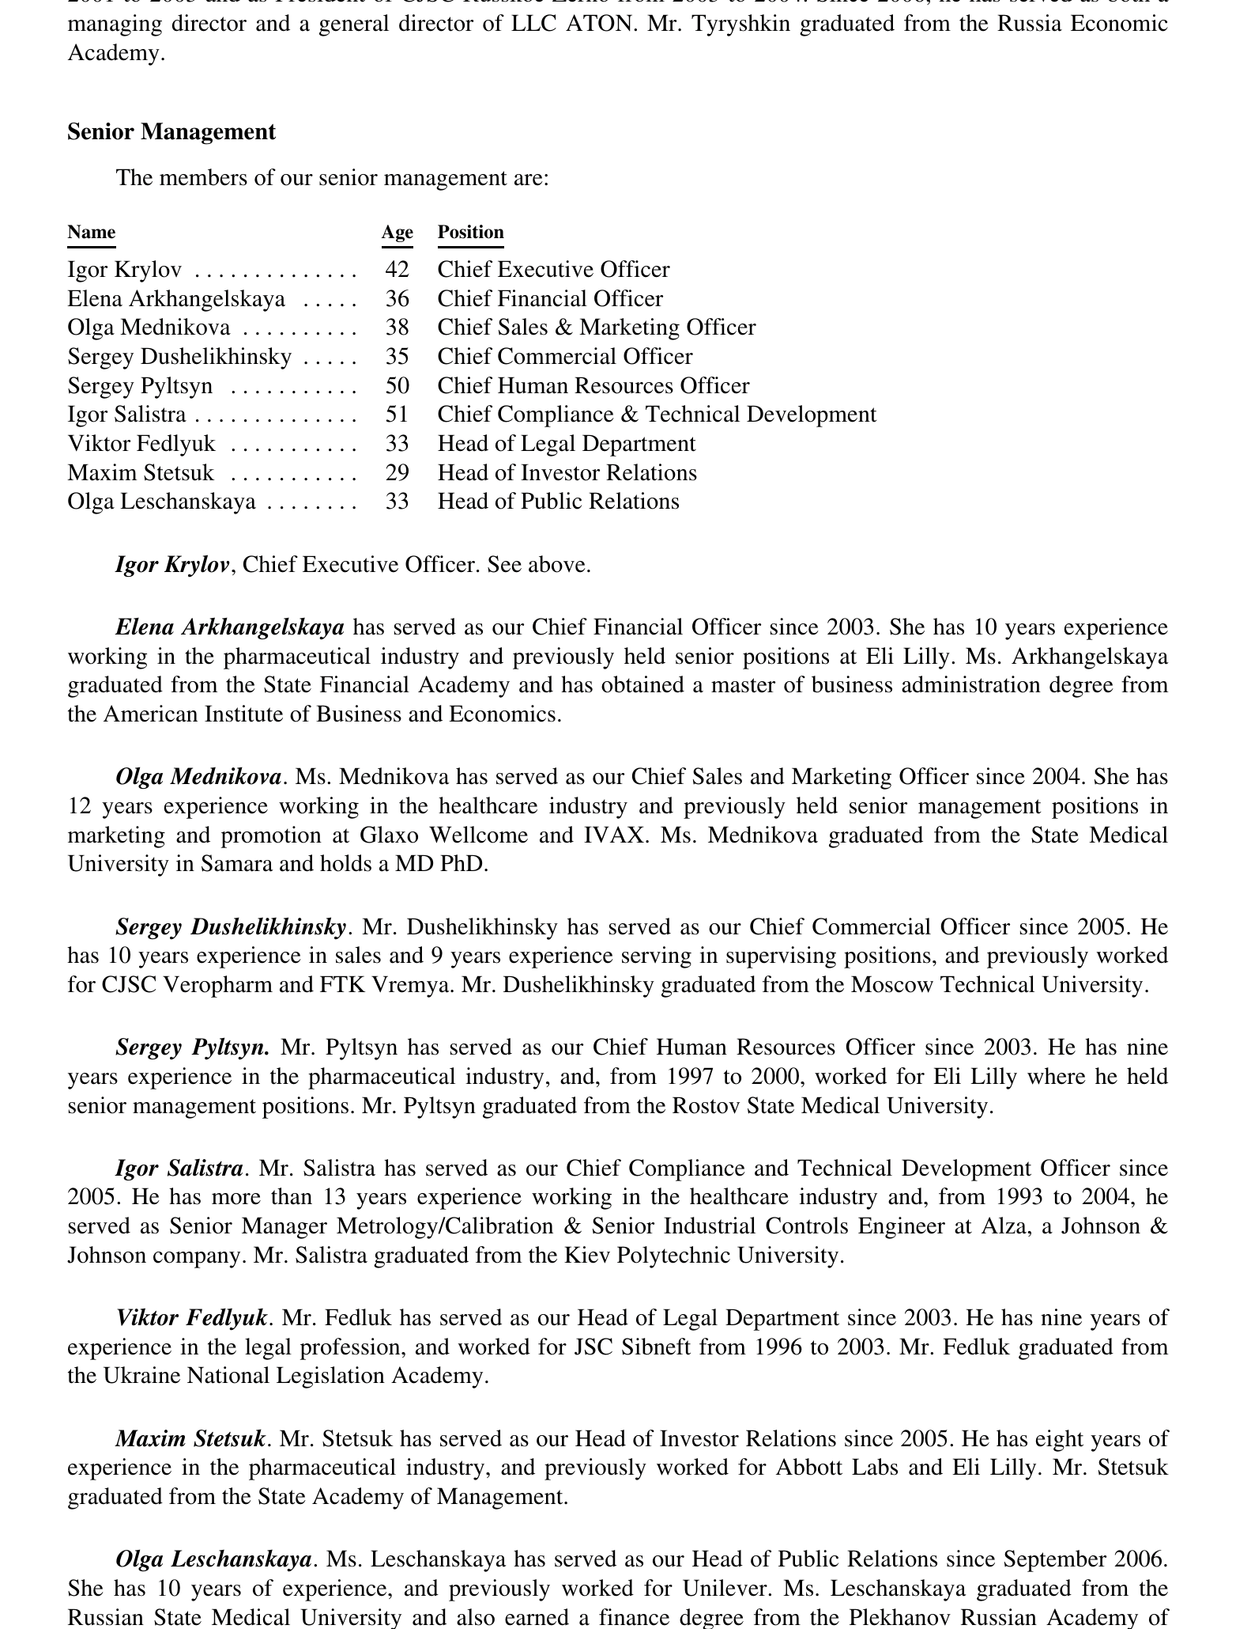
Figure 8. IPO prospectus: disclosed indirect beneficial interests before the offering.

The strictest assessment applies to physician-executives. A medical education is not a decorative biographical detail: it entails an understanding of the protective role of cough, opioid pharmacology, respiratory failure, and the duty not to present symptomatic suppression as treatment of the disease. It is precisely for this reason that the actions of the functions headed by Igor Krylov and Olga Mednikova demand particularly severe professional and ethical assessment.

11. Government decisions and inaction
Person / authority | Documented fact | Assessment
Mikhail Zurabov | Minister from 2004 to 2007; no medical education. Signed Orders No. 578 and No. 823; the latter included the exact 4.5 mg/5 mL liquid formulation in the OTC list. | A personalized regulatory decision. After public signals of misuse had already emerged, expanding or maintaining unrestricted status for the liquid codeine presentation represented a rejection of the precautionary principle.
Vladimir Starodubov | Deputy Minister; physician, surgeon, Doctor of Medical Sciences. As Acting Minister, signed Order No. 109: no more than two packs, but still without a prescription. | For a physician and health-care organisation specialist, a two-pack limit instead of a mandatory clinical gateway was a professionally inadequate measure. Two bottles could contain 20-50 daily paediatric doses.
Ramil Khabriev | Head of Roszdravnadzor from 2004 to 2007; physician, Doctor of Medical Sciences and Doctor of Pharmaceutical Sciences. His tenure encompassed the launch and early advertising. | The absence from the publicly available record of a published product-specific benefit-risk justification is a grave defect in the transparency of medicines oversight. No individual signature on the marketing authorization was established.
Nikolai Yurgel | Head of Roszdravnadzor from 2007 to 2010; physician specialising in internal medicine, Doctor of Medical Sciences. During his tenure, the instructions of 13 August 2008 were registered with codeine, OTC status, and use by children aged two years and older. | For a physician leading the regulator, the absence of a public scientific justification for the combination of paediatric age, an opioid, and unrestricted dispensing was a serious failure of regulatory governance. No individual signature on the decision was found.
Tatiana Golikova | Minister from 2007 to 2012; education in economics. During her tenure, the status was maintained and then revoked; the transition following Resolution No. 599 was deferred until 1 June 2012. | A delay of more than ten months preserved unrestricted access after the need for prescription-only (Rx) dispensing had been officially recognised. Without published compensating safeguards, this meant that the administrative transition was prioritised over immediate risk reduction.
Veronika Skvortsova | Neurologist, Doctor of Medical Sciences; Deputy Minister from July 2008. Signed the letter on transition to prescription-only (Rx) dispensing in April 2012. | Corrective action is documented. However, the presence of a physician as Deputy Minister during the period in which OTC status was maintained strengthened the professional duty to seek earlier paediatric reassessment; the allocation of responsibility for the dossier has not been published.
Government of the Russian Federation / Vladimir Putin | Resolution No. 599 was signed on 20 July 2011; the special rule for codeine took effect on 1 June 2012. | The measure corrected the dispensing status but simultaneously imposed a delay. After public recognition of the risk, retaining OTC status for more than another ten months without a disclosed protective system was a morally and administratively vulnerable decision.
FAS / advertising oversight | The law assigned advertising oversight to the antimonopoly authority. The verified public commercials for the liquid presentation continued after 1 July 2006. | The publicly available record does not demonstrate effective application of the specific prohibition to these commercials. This is a defect in institutional oversight and the transparency of enforcement.

Regional level: Sverdlovsk Region
Order No. 801-p of the Ministry of Health of the Sverdlovsk Region, dated 10 October 2006 and prompted by an increasing number of cases of abuse, expressly named Codelac Phyto among OTC codeine-containing products, limited dispensing to one pack, and recommended sale only to persons over 18 years of age. The regional measure did not constitute a full prescription filter, but it was stricter than the later federal limit of two packs. [S12, S13]
WHAT THE REGIONAL EXAMPLE PROVES
A more protective decision was administratively possible and was in fact implemented as early as 2006. The federal authorities chose a less stringent model. Publicly available documents do not establish that particular federal officials knew specifically of the Sverdlovsk order; the existence of the alternative itself is established.

The Federal Drug Control Service (FSKN) as a contrast
On 22 April 2010, FSKN Director Viktor Ivanov publicly described the spread of desomorphine made from pharmacy medicines and proposed restricting advertising for codeine-containing drugs and making them prescription-only (Rx). From that date onward, it became particularly weak for the system to claim that there had been no clear interagency signal. The FSKN did not register medicines, but it is documented to have demanded tighter restrictions. [S44]

12. Russian law and international obligations
Domestic regulatory permissibility of OTC status before 1 June 2012 does not answer the question of the quality of the regulatory decision. Three distinct levels are used for the assessment: binding Russian law; international treaties binding on the state; and professional standards and soft law, which do not in themselves create individual liability but establish a benchmark for good-faith conduct.
Level | Rule | Application to the model under review
Russian law | Resolution No. 681; Orders No. 823 and No. 109; the Law on Advertising; Resolution No. 599 | The state simultaneously controlled codeine as a List II substance, permitted a low-dose liquid formulation to be sold OTC, and later made it prescription-only (Rx). Public advertising after 1 July 2006 bore indicia of non-compliance with Part 9 of Article 24.
Convention on the Rights of the Child | Article 3: the best interests of the child are a primary consideration; Article 24: the right to the highest attainable standard of health | For administrative authorities, this standard required placing child safety above economic convenience, ensuring effective oversight, and providing parents with sufficient information.
International Covenant on Economic, Social and Cultural Rights (ICESCR) | Article 12: the right to the highest attainable standard of physical and mental health | The state’s obligation to regulate the pharmaceutical market and prevent foreseeable harm; Russia/the USSR was a party during the period under review.
WHO Ethical Criteria | Promotion should be accurate and substantiated, and should not omit information that may lead to unjustified risk; public advertising of narcotic and psychotropic drugs should not be encouraged | A professional benchmark, not a treaty. An emphasis on paediatric age in advertising without equally prominent opioid information did not comply with it.
The Russian Federation signed the Convention on the Rights of the Child on 26 January 1990 and ratified it on 16 August 1990. The USSR signed the ICESCR on 18 March 1968 and ratified it on 16 October 1973; the Russian Federation continued its participation. Articles 3 and 24 of the Convention and Article 12 of the Covenant are therefore obligations of the state, not voluntary corporate recommendations. [S39-S42]
The treaty obligation is borne directly by the state, but the state is required to protect children from the actions of private market participants as well. For business, the legally and ethically relevant standards include national requirements, the registration dossier, pharmacovigilance, the Law on Advertising, the corporate duty of oversight, and internationally recognised due diligence. The WHO criteria constitute a professional measure of the quality of promotion, but do not replace the law. [S39, S43]
OVERALL HUMAN-RIGHTS ASSESSMENT
A system in which a government regulator permitted unrestricted administration of an opioid at home to a two-year-old child, while the manufacturer emphasised the paediatric age to a mass audience without comparable risk disclosure, did not comply with the priority of the child’s best interests or the high standard of health protection. This is a conclusion about the quality of decisions and institutions, based on documents and binding principles.

13. International practice, 2000-2013
The lower age threshold of two years was not absolutely unique: some German prescription-only codeine cough products retained that minimum age until 2013. However, the Russian combination of “two years of age + OTC + federal mass advertising + a bottle kept at home containing 10-25 paediatric daily doses” lay at the extremely permissive edge of international practice.
Jurisdiction / date | Policy | Comparison
WHO, 2001 | Found no basis for recommending codeine cough preparations for young children; emphasised weak evidence of benefit and risks. | The scientific signal existed before the advertising campaign and the IPO.
United States, 2000s | Comparable codeine products were prescription-only or were dispensed by a pharmacist under the controlled Schedule V regime; paediatric restrictions were stricter. | Not an unrestricted mass-market product without a professional gateway.
United Kingdom, 2010/2011 | All liquid OTC codeine cough products were excluded for persons younger than 18 years. | At that time, the Russian instructions still covered children aged two years and older.
Australia, 2012 | Cough/cold medicines were not to be used in children younger than 6 years; for children aged 6-11, only on the advice of a physician or pharmacist. | An age and professional gateway.
Germany, until 2013 | Some prescription-only syrups were authorised from two years of age; the age threshold was raised to 12 years in 2013. | A counterexample to the absolute uniqueness of the age threshold, but not to the Russian OTC-plus-advertising combination.
EMA, review begun in 2014, outcome in 2015 | Codeine for cough was contraindicated in children younger than 12 years; liquid presentations were to be supplied in child-resistant containers. | Later formal recognition of the mechanism: variable conversion into morphine and limited benefit.

14. Timeline of key decisions
Date | Event
1978 | The AAP describes the protective function of cough and the risk of suppressing it when secretions are excessive.
1993 | A paediatric placebo-controlled RCT shows no advantage of codeine/guaifenesin over placebo.
1997 | The AAP again points to the absence of proven efficacy in children and the risk of toxicity.
2001 | The WHO does not recommend codeine cough preparations for young children.
2003 | A cohort of children aged 0-4 years shows that half cough for up to 10 days and 10% for up to 25 days.
2004 | A later prospectus dates the launch of Codelac Phyto for treating cough symptoms in children to this year.
2005 | The Codelac advertising campaign begins; the broadcast advertisement says “syrup for children aged two years and older.”
1 July 2006 | The new Law on Advertising takes effect, with a specific restriction covering medicines that contain substances included in Lists II/III.
10 October 2006 | The Sverdlovsk Region records an increasing number of cases of abuse, limits Codelac Phyto to one pack, and recommends sale only to persons over 18.
11 January 2007 | Federal inclusion of the exact 4.5 mg/5 mL liquid formulation in the OTC list takes effect.
12 February 2007 | Federal Order No. 109 permits no more than two packs but does not introduce prescription-only (Rx) status.
13 August 2008 | The GRLS records instructions for registration No. R N002419/01: opioid; children aged two years and older; dependence; respiratory risks; “Without a prescription.”
22 April 2010 | The FSKN publicly calls for restrictions on advertising codeine products and for prescription-only (Rx) dispensing.
20 July 2011 | The Government adopts Resolution No. 599, but defers the prescription-only rule for codeine until 1 June 2012.
1 June 2012 | Codeine combinations become prescription-only (Rx).
2012 | A corporate report records a 68% decline in sales of codeine-containing Codelac.
2013 | European regulators tighten paediatric use of codeine; Germany raises the minimum age for cough products to 12 years.

15. Final assessment
- Codelac Phyto was not simply a herbal syrup, but an opioid elixir; this follows from its own official instructions.
- Paediatric benefit from codeine for acute cough had not been convincingly demonstrated even before launch, while the protective role of cough and the risk of toxicity were known.
- OTC status transferred to parents a clinical decision that required assessment of the cause of cough, respiratory reserve, drug interactions, and individual metabolism.
- In pneumonia and productive cough, codeine created a dual risk: poorer clearance of secretions and reduced respiratory drive.
- The liquid dosage form heightened foreseeable risks of measurement error, prolonged use, and accidental access to a multi-dose supply.
- Advertising turned the minimum age of two years into a commercial argument and did not communicate, with comparable prominence, the opioid nature, morphine, dependence, and respiratory depression.
- For Pharmstandard’s physician-executives, this communication and the continued OTC model represented a grave professional and ethical failure.
- For the owners and the board of directors, it represented a failure of corporate oversight: a major economic interest demanded independent medical review and risk controls.
- For federal authorities, it represented a failure of precaution and transparency: more protective options were known and had been partially implemented by regional authorities long before the 2012 prescription requirement.
- The late transition to prescription-only (Rx) status confirmed that the risk was controllable, but left unanswered why the mandatory clinical gateway had not been introduced earlier.
FINAL FORMULATION
The company created and scaled a product model of “opioid + children aged two years and older + OTC + mass advertising.” Government authorities permitted this model through regulation, supervised it inadequately, and did not terminate it until 2012. From the perspectives of evidence-based pediatrics, medicines safety, corporate ethics, and the primacy of the child’s interests, this model was unacceptable.

Sources
Links were checked as of 5 August 2026. Primary government and corporate documents take precedence; scientific and international sources are used for the clinical and pharmacological assessment.
[S01] Russian Ministry of Health GRLS: official scan of the instructions, registration No. R N002419/01-130808
[S02] GRLS: historical record for Codelac Phyto, registration No. R N002419/01
[S03] OJSC Pharmstandard, Offering Memorandum / Prospectus, 4 May 2007
[S04] OJSC Pharmstandard: Annual Report 2007
[S05] OJSC Pharmstandard: Annual Report 2012
[S06] Resolution No. 681 of the Government of the Russian Federation: codeine and codeine phosphate in List II
[S07] Order No. 823 of the Russian Ministry of Health and Social Development, 4 December 2006
[S08] Consolidated list under Order No. 578, including the 4.5 mg/5 mL formulation
[S09] Resolution No. 599 of the Government of the Russian Federation, 20 July 2011
[S10] Russian Ministry of Health and Social Development: transition of codeine combinations to prescription-only (Rx) status from 1 June 2012
[S11] Federal Law No. 38-FZ “On Advertising,” original version
[S12] Order No. 801-p of the Ministry of Health of the Sverdlovsk Region, 10 October 2006
[S13] Order No. 109 of the Russian Ministry of Health and Social Development, 12 February 2007
[S14] WHO, Cough and Cold Remedies for the Treatment of Acute Respiratory Infections in Young Children, 2001
[S15] AAP Committee on Drugs: protective role of cough and risk of suppression in the presence of secretions, 1978
[S16] AAP: codeine- and dextromethorphan-containing cough remedies in children, 1997
[S17] Taylor et al.: placebo-controlled trial of cough suppressants in children, 1993
[S18] ACCP/CHEST: diagnosis and management of cough; paediatric recommendation, 2006
[S19] Hay et al.: duration of acute cough in preschool children, 2003
[S20] BMJ systematic review: duration of symptoms of respiratory infections in children, 2013
[S21] CDC: clinical signs and symptoms of influenza
[S22] CDC: acute bronchitis
[S23] NICE: acute cough and bronchitis - terms and expected duration
[S24] NICE: evidence summary for acute cough; codeine and paediatric restrictions
[S25] AAP/HealthyChildren: pneumonia in children and cough suppressants
[S26] CDC: clinical features of Mycoplasma pneumoniae infection
[S27] EMA: codeine-containing medicinal products for the treatment of cough or cold in paediatric patients
[S28] EMA Pharmacovigilance Risk Assessment Committee: restrictions and child-resistant containers for liquid codeine medicines
[S29] Health Canada: paediatric respiratory events involving codeine for cough
[S30] DailyMed: opioid antitussive warnings concerning productive cough and respiratory depression
[S31] CPIC guideline for CYP2D6 genotype and codeine therapy
[S32] AAP: iatrogenic opioid dependence and withdrawal in children, 2014
[S33] Yin et al.: liquid-medication dosing errors by caregivers
[S34] CDC: emergency visits involving cough/cold medicines and unsupervised ingestion
[S35] Voronov et al.: apnoea and brain injury in a 29-month-old CYP2D6 ultra-rapid metabolizer
[S36] UK MHRA: codeine-containing liquid OTC medicines, 2010/2011
[S37] Australia: medicines safety update on cough/cold medicines in children, 2012
[S38] BfArM: historical German paediatric codeine products and changes to age restrictions
[S39] UNICEF: full text of the Convention on the Rights of the Child
[S40] United Nations Treaty Collection: Russian Federation ratification of the Convention on the Rights of the Child
[S41] Office of the United Nations High Commissioner for Human Rights: International Covenant on Economic, Social and Cultural Rights
[S42] United Nations Treaty Collection: ICESCR status for the Russian Federation
[S43] WHO/WHA41.17: Ethical Criteria for Medicinal Drug Promotion, 1988
[S44] Rossiyskaya Gazeta: FSKN position on codeine and desomorphine, 22 April 2010
[S45] TASS: Roman Abramovich’s education
[S46] Forbes: Evgeny Shvidler’s education and business experience
[S47] Moscow State University Chronicle: Viktor Kharitonin, Novosibirsk State University, and Pharmstandard

Appendix: documentary images
The images below are copies of the official instructions, the corporate prospectus, and archived advertising frames. The links in the source list provide the full context for verification.

Appendix 1. Composition and opioid pharmacotherapeutic group

Appendix 2. Paediatric age-specific doses and the dependence warning

Appendix 3. Manufacturer and the “Without a prescription” dispensing condition

Appendix 4. Prospectus: launch of Codelac Phyto for treating cough symptoms in children
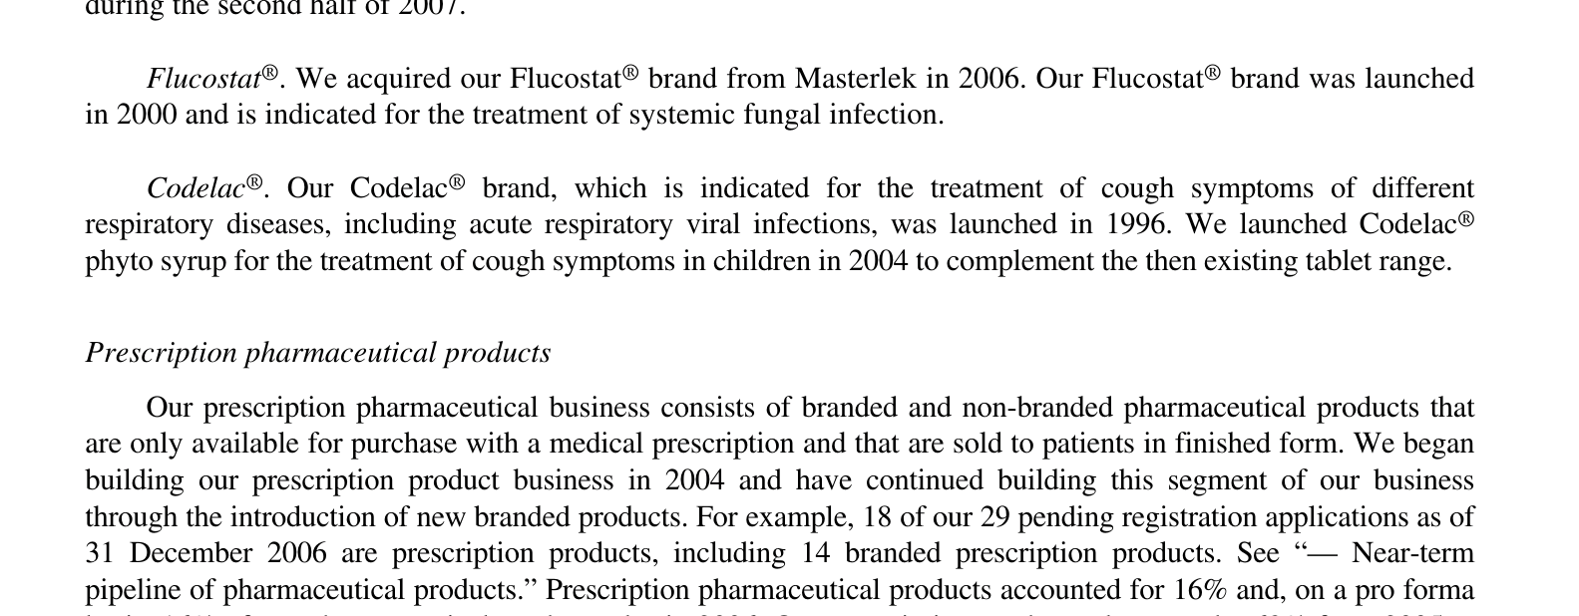

Appendix 5. Archived frame of the 2005 advertising claims

Appendix 6. Archived final frame for the 2005 liquid presentation

Appendix 7. Archived 2006 packshot showing registration No. 002419/01

